Муниципальное общеобразовательное учреждение
«Кузнечихинская средняя школа»
Ярославского муниципального района

Методическая разработка

Квест по английскому языку «Travelling to English»

Подготовил: Алексеева Анна Викторовна,
учитель английского языка,
1 квалификационной категории

д. Кузнечиха, 2018
Аннотация
Целью написания данной разработки является желание поделиться опытом по проведению внеклассного мероприятия по английскому языку в форме квеста для 7-8 классов.
Мероприятие было разработано в рамках курса внеурочной деятельности по английскому языку «Страноведение».
Игра помогает актуализировать лингвострановедческие знания по истории, географии, культуре Великобритании; способствует развитию неподготовленной устной речи учащихся. Данное мероприятие активизирует повторение ранее изученного предметного материала, формирует и закрепляет приобретенные учащимися метапредметные результаты, способствует развитию коммуникабельности и повышению познавательной активности участников.
Планируемые результаты
- Личностные: развитие мотивации, познавательного интереса к предмету; формирование коммуникативных навыков; развитие внимания, памяти, сообразительности, логического мышления;
- Метапредметные: коммуникативные умения; межличностное взаимодействие и сотрудничество; критическое и системное мышление;
- Предметные: знание лексики, грамматики и страноведческого материала в рамках тематики; использование приобретенных знаний в коммуникативных ситуациях; закрепление раннее изученной лексики.

Ход мероприятия
Игра проходит по станциям (money, vocabulary, people and places, country study, symbols, be kind, letter)
Вступительное слово:
Hello, everybody! We have a book about English, but someone has stolen all information from it. So, it’s empty. We think that you have learnt a lot about the English language. And our task is to collect all facts to fill the book. We have 7 stations. Now you are going to get your route lists and so-called “books”. During our quest you will find out different facts. So, at the end of the game you will have a full book about English. So, let’s start! (Приложение 1)
Station 1: our station is called “Money”. There you can get a lot of money! There are different hidden tasks. For every task that you can find and do, we will give you some money. You have to stick them to your book! There you can get maximum 20 points. Ready, steady, go! (Приложение 2)
Station 2: our station is called “Vocabulary”. Your task is to divide the words into 5 columns. Then you should stick these words into the table (it’s in your book). There you can get 20 points. You have 5 minutes for this task. (Приложение 3)
Station 3: our station is called “People and places”. You’ll see 20 pictures. Your task is to name a famous person or a place. After answering you should stick the picture into your book. You will get 1 point for every right answer. (Приложение 4)
station 4: our station is called “Country study”. Your task is to match a country with its capital and its flag. For this task you can get 20 points and small pictures with information for your book. You have 5 minutes. (Приложение 5)
station 5: our station is called “Symbols”. Your task is to make up four puzzles and name what is in the pictures. For this task you can get 20 points and smaller pictures for your book. You have 5 minutes. (Приложение 6)
6 station: our station is called “Be kind”. Now you are going to watch a cartoon. After watching you should write a short story about animal’s help to people. Also you should draw a picture to illustrate your story. You can get 20 points for this task. You have 10 minutes. (Приложение 7)
7 station: our station is called “Letter”. Now you have to remind how to write a personal letter. Your task is to make a plan of the letter and to stick it to your book. Then you should make a letter from the proposed phrases. For this task you’ll get 10 points. You have 5 minutes. (Приложение 8)
The results: our judges will collect your points and tell us the results.

Приложение 1
The route list of ______ (the name of a team)
The name of the station | The place
Country study
Symbols
People and the places
Money
Vocabulary
Be kind

The route list of ______ (the name of a team)
The name of the station | The place
The symbols
People and places
Money
Vocabulary
Be kind
Country study

Приложение 2
Задания:
- Name 7 colors of the rainbow.
- Make someone laugh.
- Give everyone a piece of advice.
- For a minute draw someone's portrait.
- Speak about cats for at least 1 minute without stopping.
- Sing a song.
- Name five creatures that live in the sea.
- For a minute name 10 film with dogs in it.
- Do ten sit-ups.
- Go outside and shout “I’m a Monster!” as loud as you can.
- Without words, show that you are busy at work.
- For a minute without words show 10 emotions.
- Say «Peter Piper picked a peck of pickled peppers» five times.
- Tell a poem.
- Dance for 2 minutes.
- Say 3 times «Three witches watch three swatch watches».
- Say 10 words with the letter “W”.
- Make a compliment to everybody.
Награды:
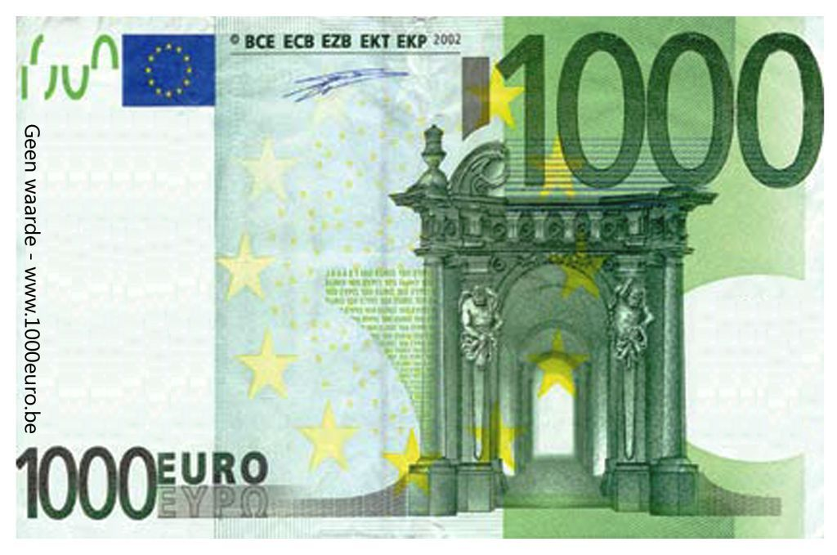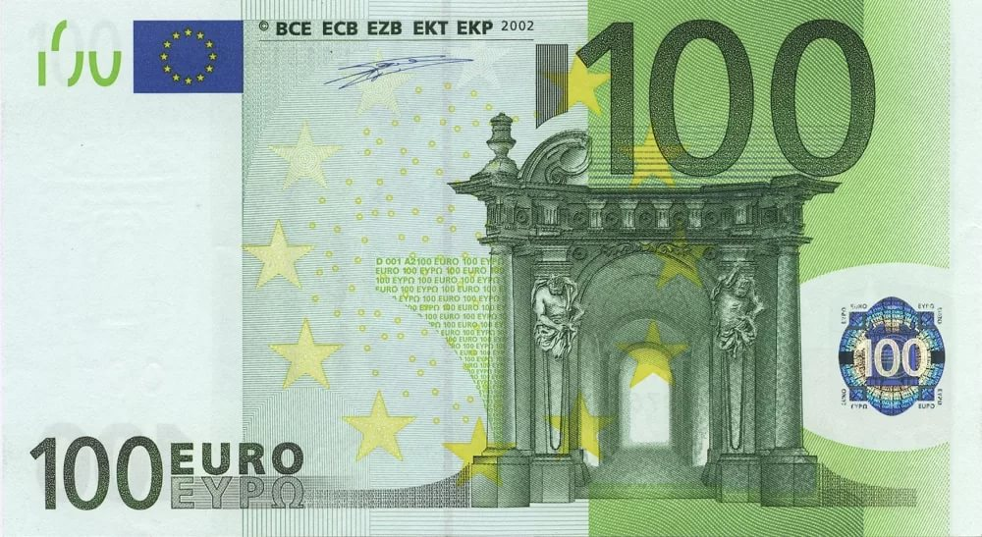
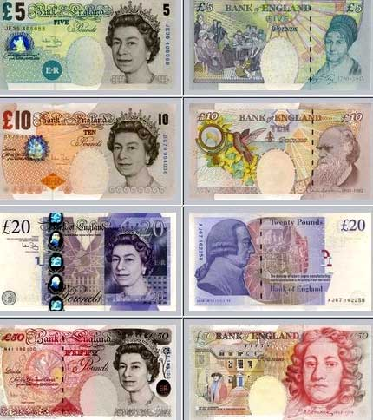

Приложение 3
Слова для распределения на категории:
Rainy | Kitchen | Armchair | Daughter | Rubber
Sunny | Bedroom | Fireplace | Son | Ruler
Cloudy | Bathroom | Picture | Brother | Textbook
Cold | Hall | Sofa | Grandmother | Pencil
Warm | Living room | Carpet | Uncle | Pencil – box
Ответы:
Weather | House | Room | Family | School bag
Rainy | Kitchen | Armchair | Daughter | Rubber
Sunny | Bedroom | Fireplace | Son | Ruler
Cloudy | Bathroom | Picture | Brother | Textbook
Cold | Hall | Sofa | Grandmother | Pencil
Warm | Living room | Carpet | Uncle | Pencil – box

Приложение 4
Иллюстрации
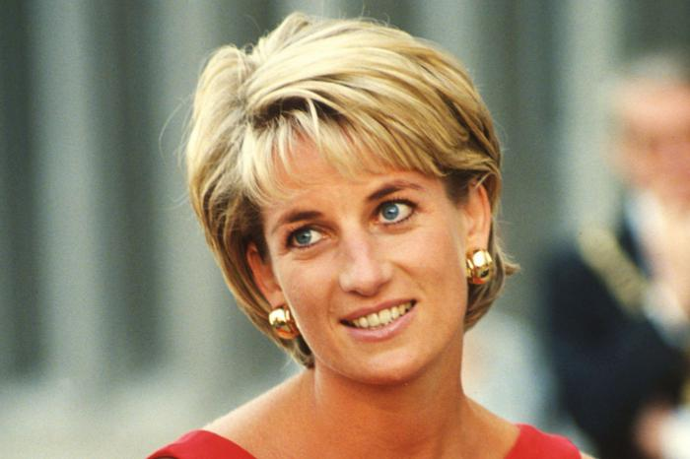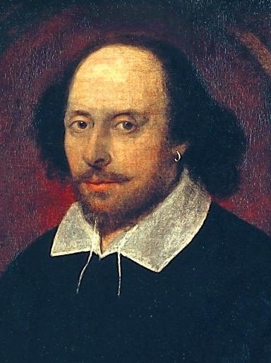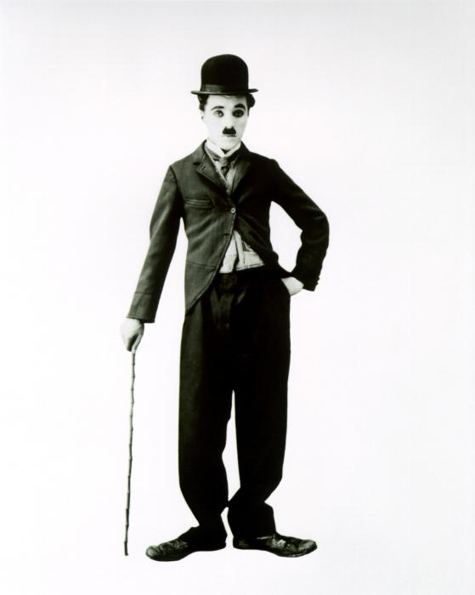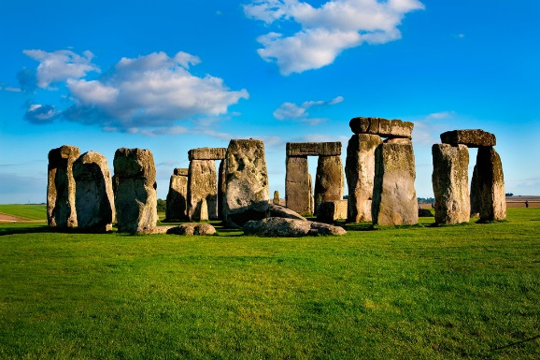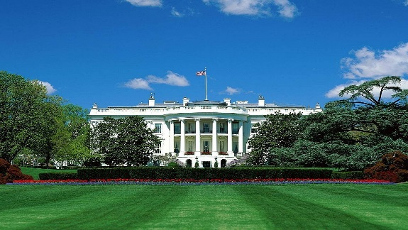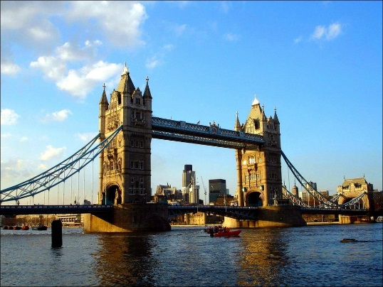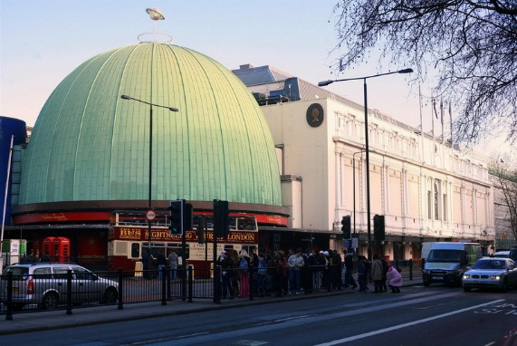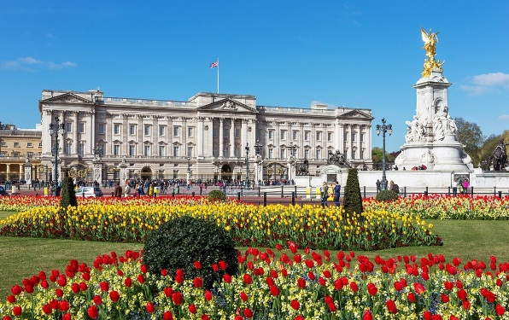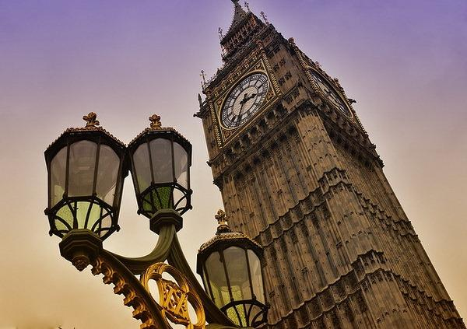
Answers:
1) Princess Diana
2) Queen Elizabeth 2
3) Statue of liberty
4) Daniel Radcliffe
5) Obama
6) Shakespeare
7) Madonna
8) Schwarzenegger
9) Beckham
10) Chaplin
11) Stonehenge
12) Trump
13) White house
14) Tower bridge
15) Big Ben
16) Madame Tussauds Museum
17) Buckingham Palace
18) Jolie
19) Johnny Depp
20) Jim Carrey

Приложение 5
Ответы:
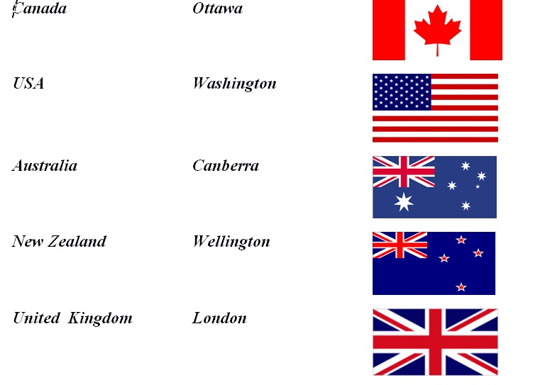

Приложение 6
Ответы:
The red rose is a symbol of England.

The shamrock is a symbol of Northern Ireland.
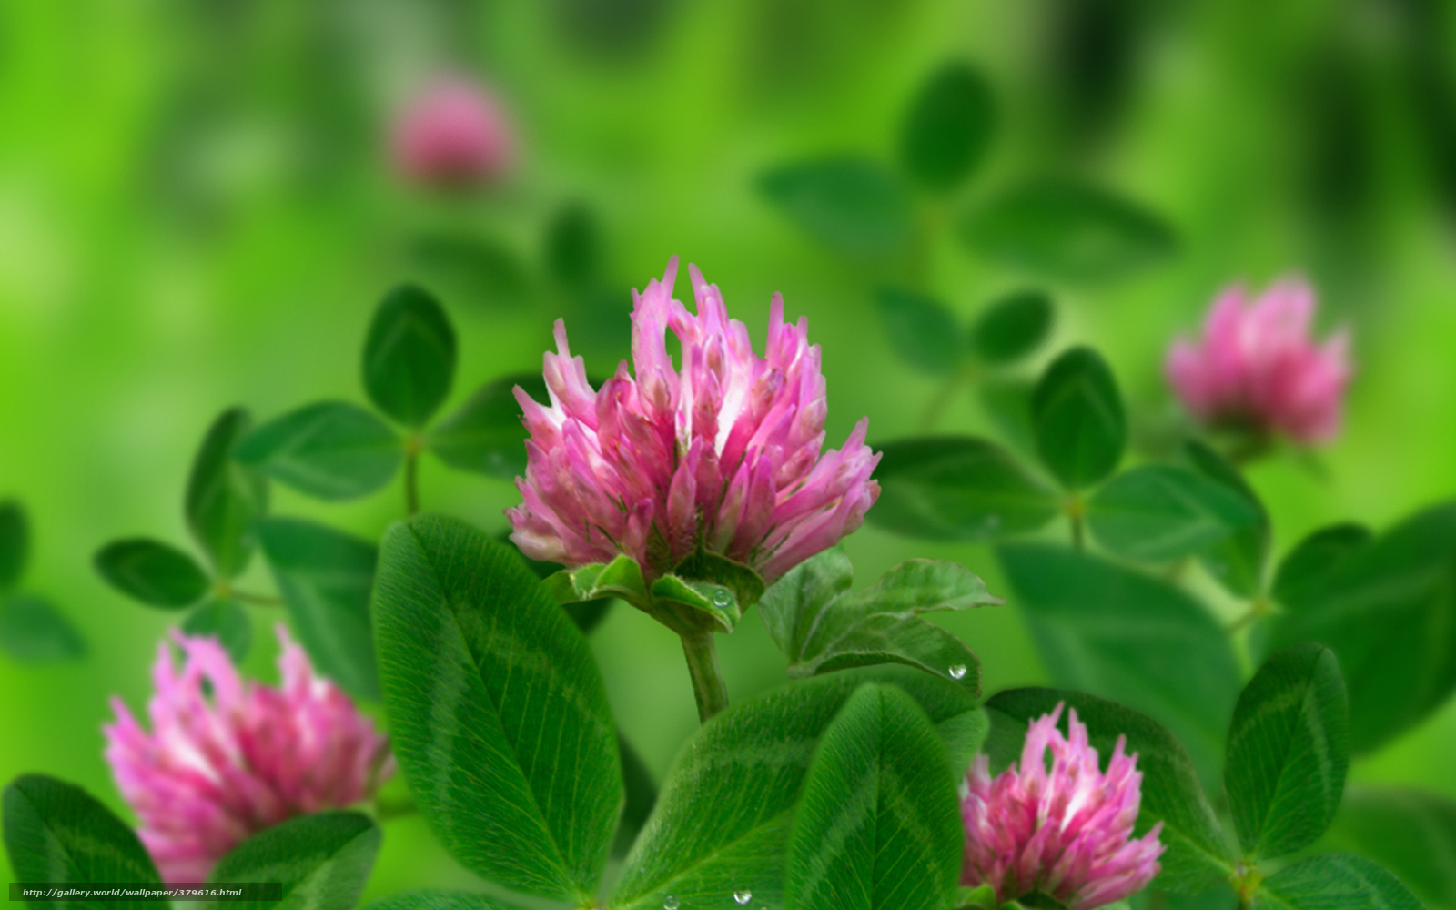
The daffodil is a symbol of Wales.
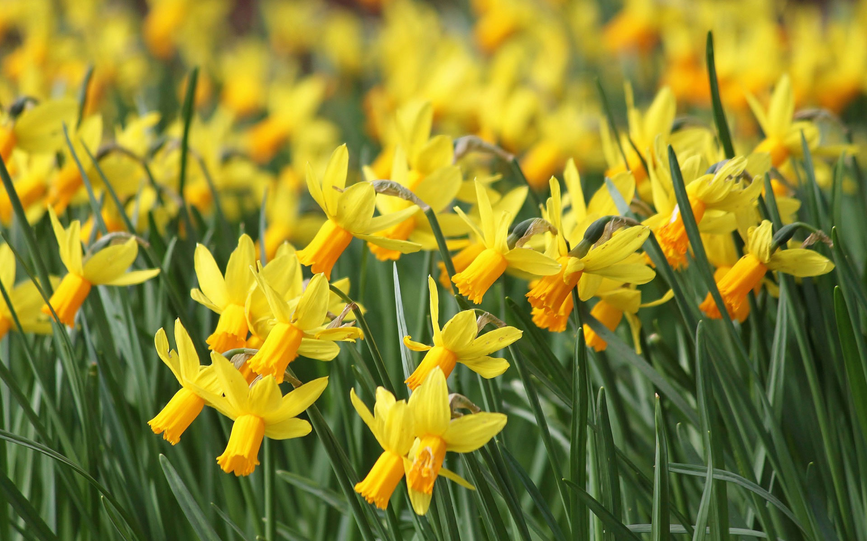
The thistle is a symbol of Scotland.
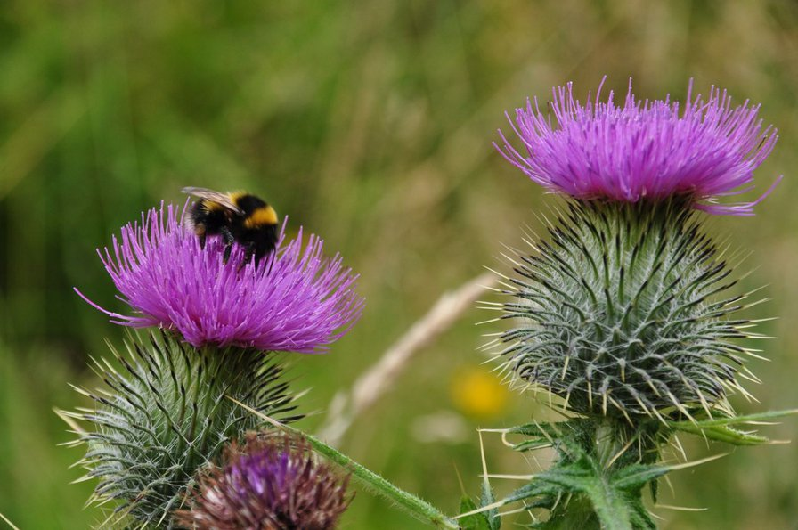

Приложение 7
Ссылка на мультфильм
http://learnenglishkids.britishcouncil.org/en/short-stories/dick-whittington
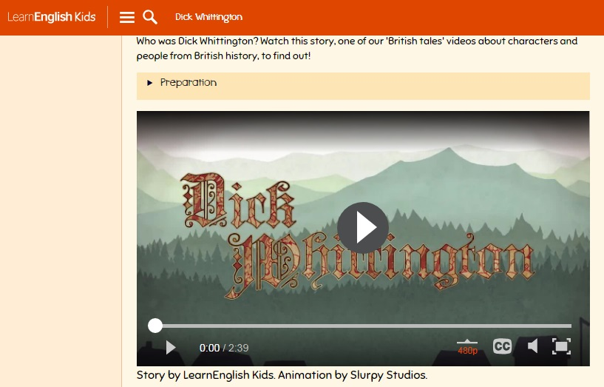

Приложение 8
Задание (структура письма)
Адрес пишущего
Дата написания
Обращение
,
Благодарность, извинение
,
Основная часть
Упоминание о дальнейших контактах
Завершающая фраза
Подпись автора

Задание (восстановить письмо)
,
Ilona
Lots of love

Well, in Russia we don’t pay much attention to clothes but of course everybody wants to look great! Actually, any clothes will do if a person feels comfortable. As for me, I usually wear a skirt and a smart blouse. You were quite right not to take any notice of your friend’s clothes. If I were you, I would have done the same. It’s not the clothes that count, after all.
By the way, what birthday presents did you get? Did your parents give you what you wanted? What presents did you like most of all? As for me, I prefer books.

,
I’d better go now. Mum wants me to help with the housework. Take care and stay in touch!
Dear Patricia
13 Gagarina StreetKazan
Russia
20/09/11

Thanks for your letter. I’m glad your birthday party was a great success!
Ответы:
13 Gagarina Street
Kazan
Russia
20/09/11
Dear Patricia,
Thanks for your letter. I’m glad your birthday party was a great success!
Well, in Russia we don’t pay much attention to clothes but of course everybody wants to look great! Actually, any clothes will do if a person feels comfortable. As for me, I usually wear a skirt and a smart blouse. You were quite right not to take any notice of your friend’s clothes. If I were you, I would have done the same. It’s not the clothes that count, after all.
By the way, what birthday presents did you get? Did your parents give you what you wanted? What presents did you like most of all? As for me, I prefer books.
I’d better go now. Mum wants me to help with the housework. Take care and stay in touch!
Lots of love,
Ilona

